# The testing items for system functionalities.

The analysis data is presented by graphic results from the website based on tweet data in Chicago. This data is analyzed into six areas: languages, devices, followers, topics, sentiment analysis as well as decent tweets on the Google map.

## Languages

Language is one of system functionalities, showing the language distribution in the Chicago. Users have the ability to perceive which one language dominates this area or which one language is prevalent in Chicago. The diagram 2.1 depicts the results of the language distribution.

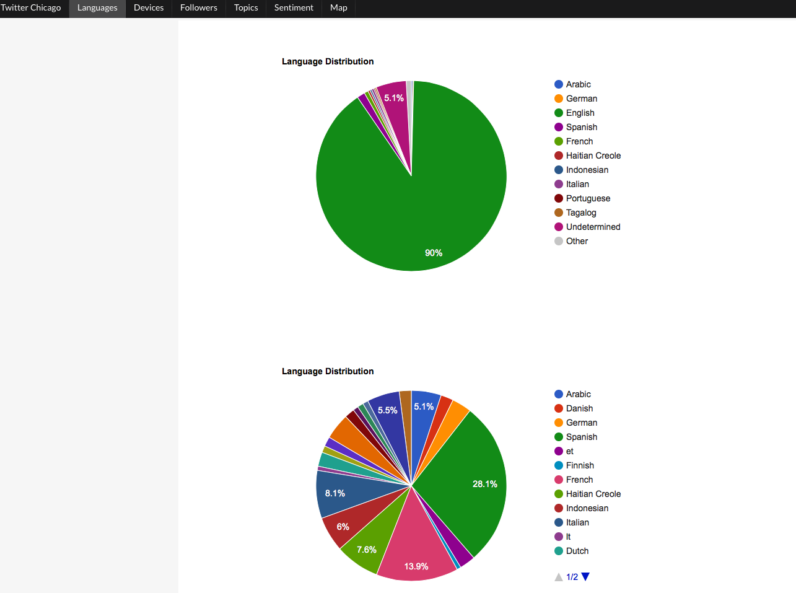

Diagram 2.1: Results of the language distribution

## Devices

Device is a webpage that users can comprehensively understand how people connect to twitter by devices. This also provides the device distribution for data analysis. The diagram 2.2 illustrates results of the device distribution.

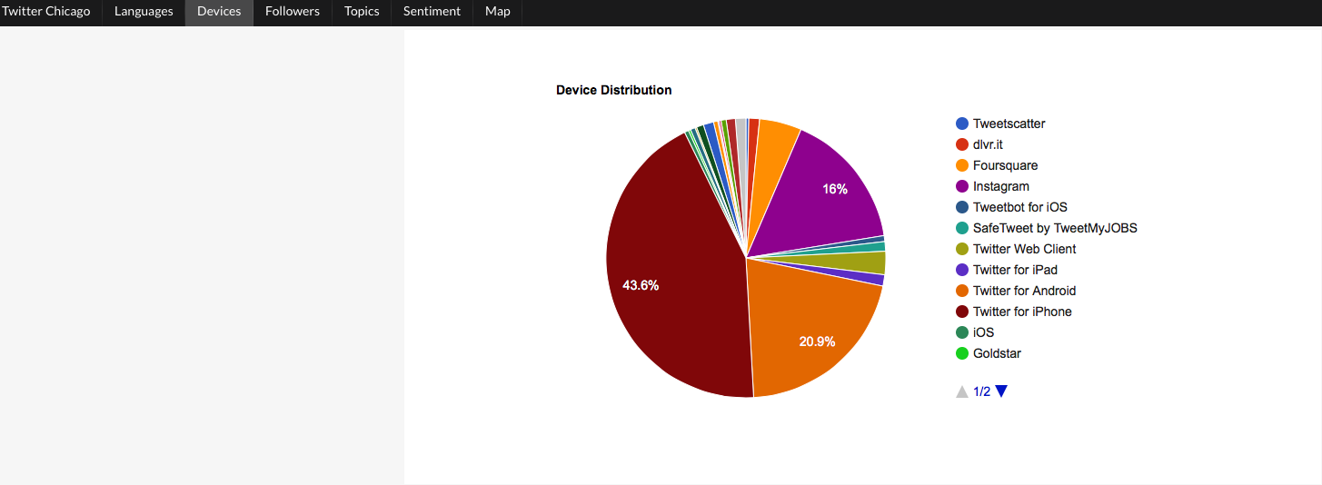

Diagram 2.2: results of the device distribution

## Followers

Followers webpage presents an analysis data of who have the most followers in Chicago as well as is shown by bar char. The diagram 2.3 shows results of the top 10 people who have most followers.

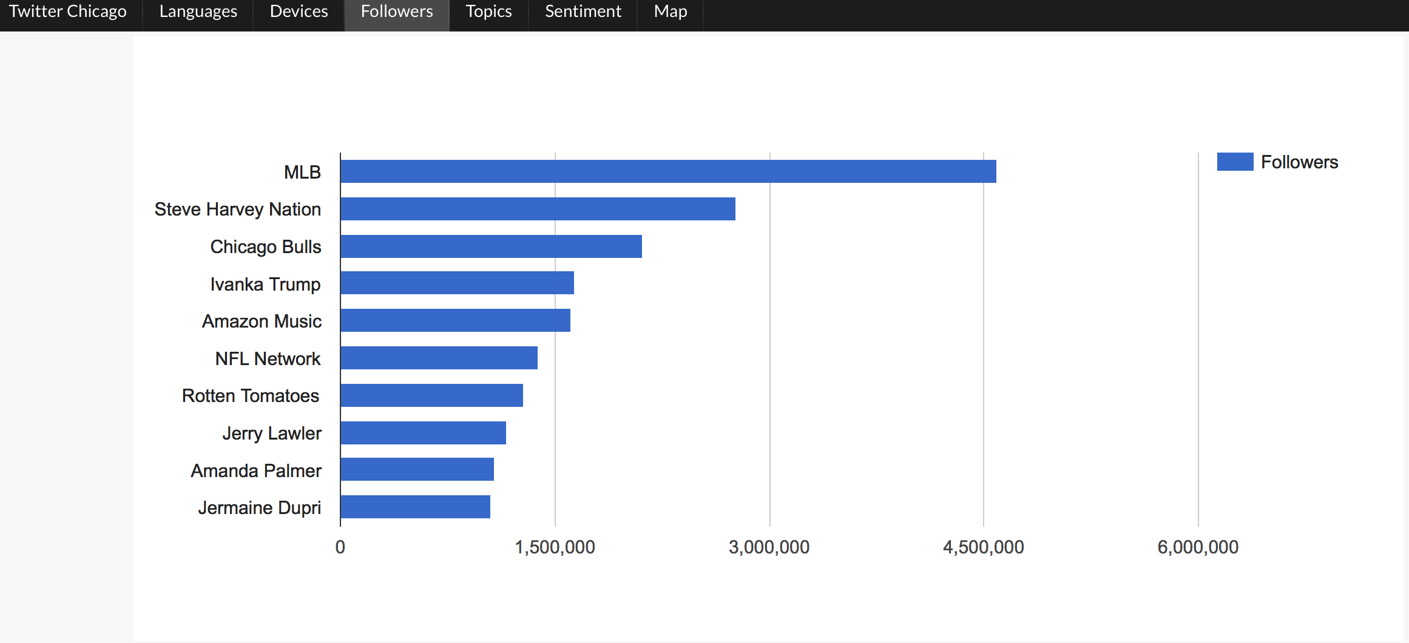

Diagram 2.3: Results of the top 10 most followers

## Topics

Topic webpage presents people who live in Chicago are interested in what kind of latest topics are. This information is illustrated by bar char and shown how may tweet counts are related to. The diagram 2.4 depicts results of the top 10 topics in Chicago.

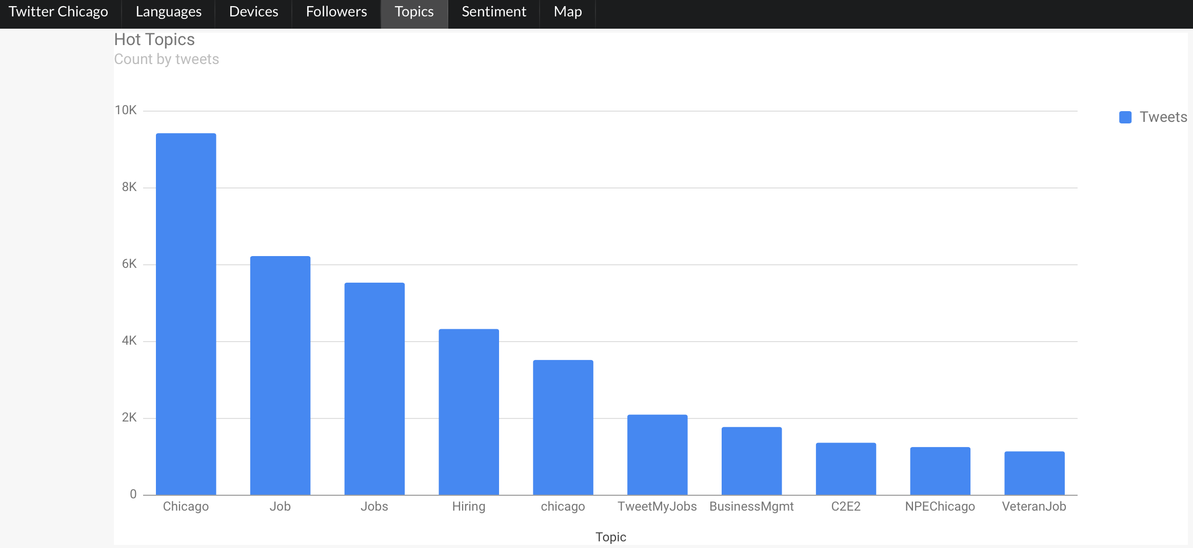

Diagram 2.4: Results of the top 10 topics

## Sentiment

Sentiment webpage presents people live in Chicago have positive or negative attitude regarding to C2E2 topic. The range of sentiment is from -1 and 1. The positive number presents that people are willing to look into this topic; however, the negative number illustrates that people have concern about this topic. The diagram 2.5 shows the results of the sentiment analysis by scatter char.

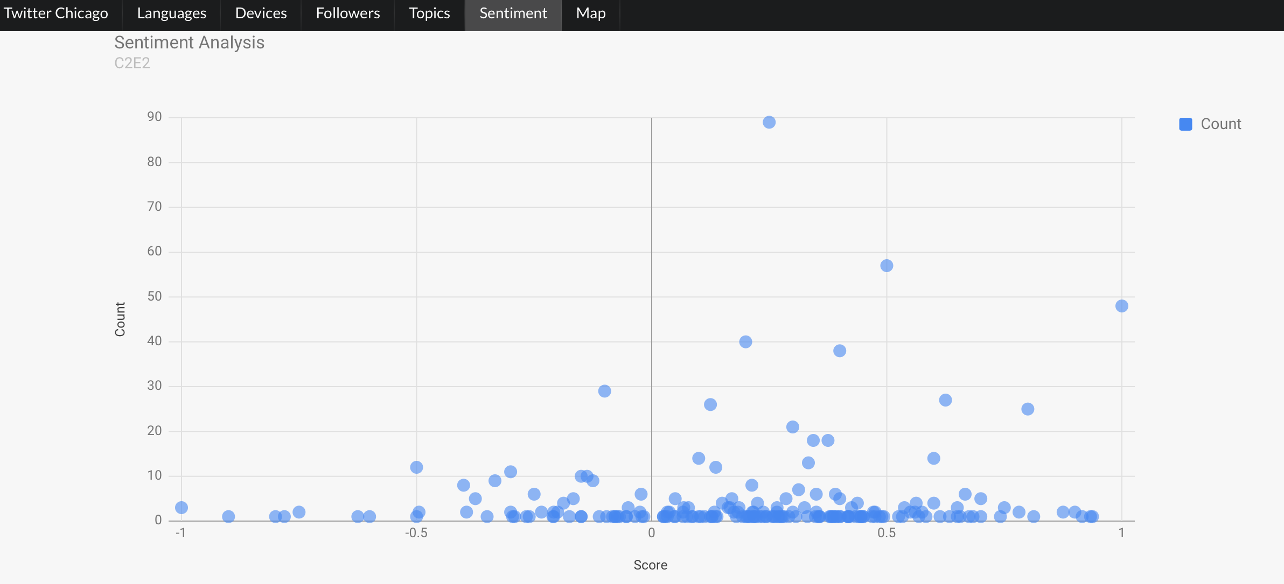Diagram 2.5: Results of the sentiment analysis

## Map

Map webpage shows that the latest 100 tweet data in Chicago, presenting by the Google Map. Users are able to know the coordination of tweet data, who send this message and what the message is. The diagram 2.6 shows results of the latest 100 tweet data on the Google Map.

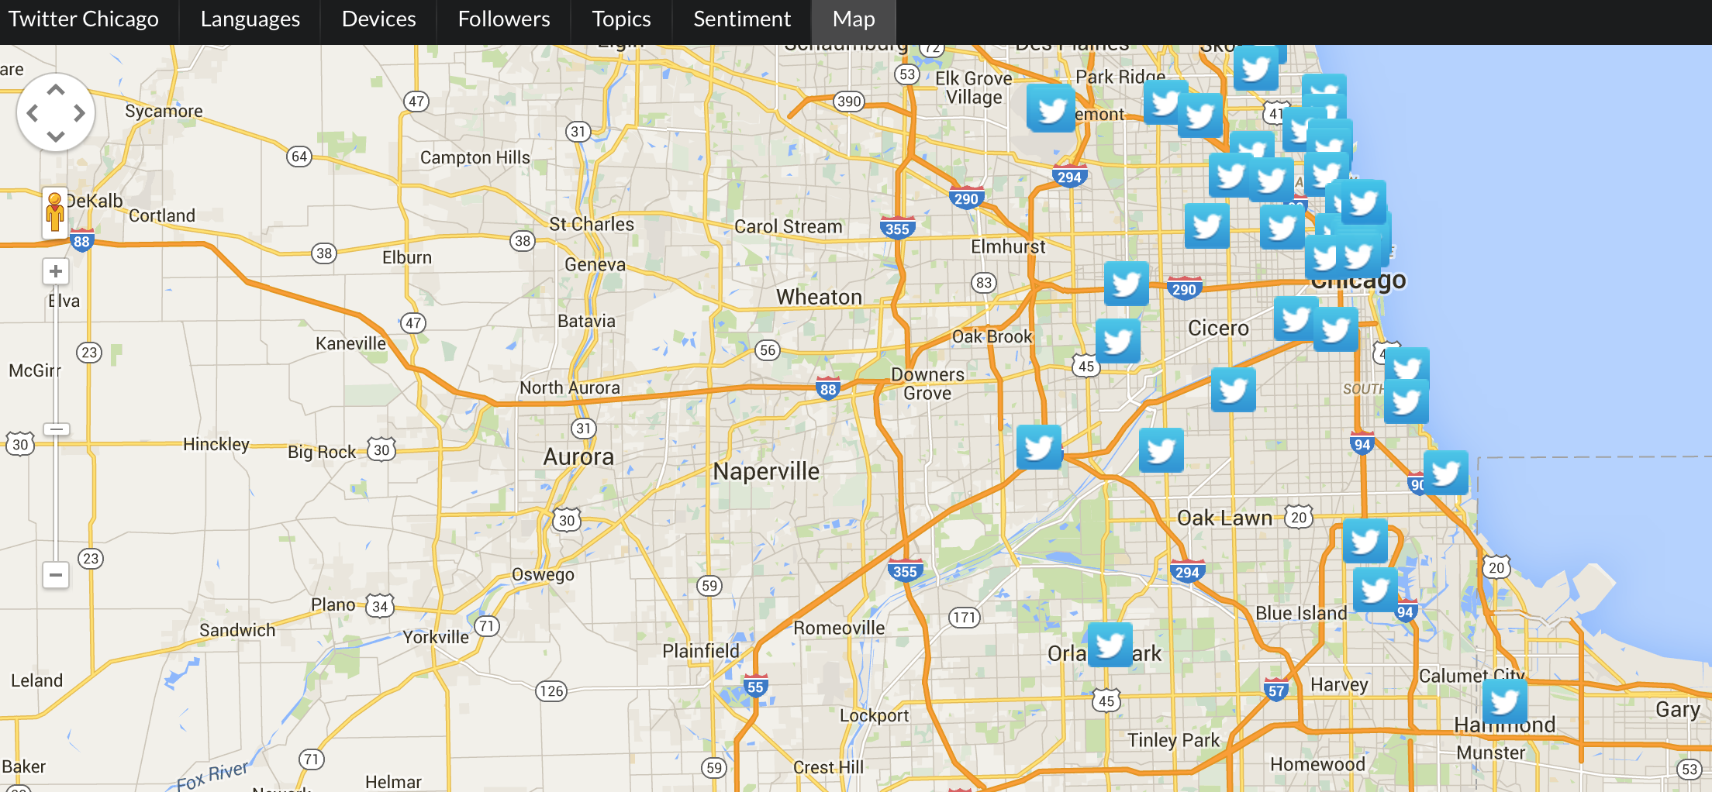

Diagram 2.6: Results of the latest 100 tweet data